Test Case 1: This solution works for 4-Queen's problem. We just need to replace the given 8-Queen's solution with a 4-Queen's one:

Changes in Code:

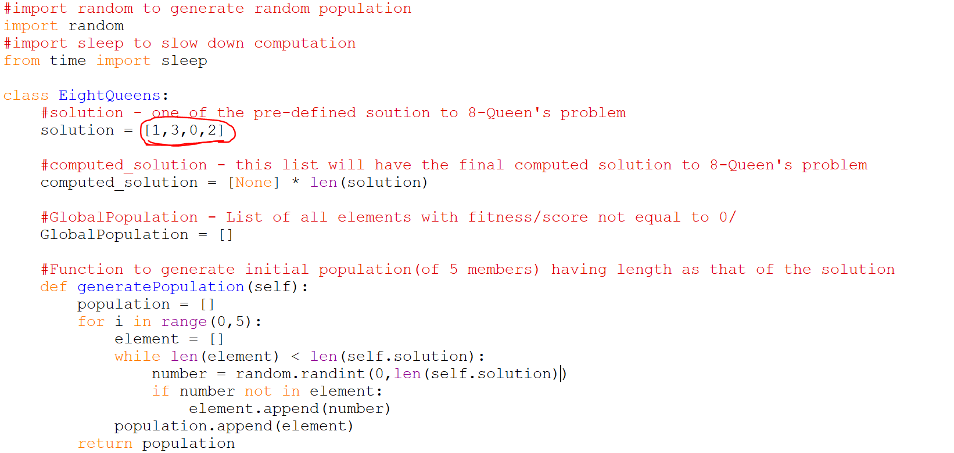

Output of the changed code:

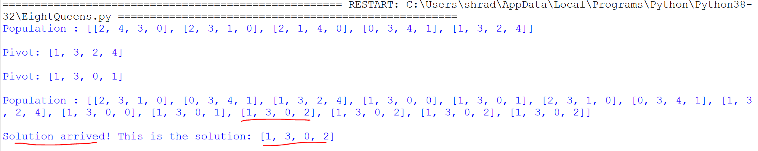

Conclusion: The code works for smaller or larger solutions.

Test Case 2: This solution works with other 8-Queen’s solution too, like 0,4,1,5,2,6,3,7

Changes in Code:

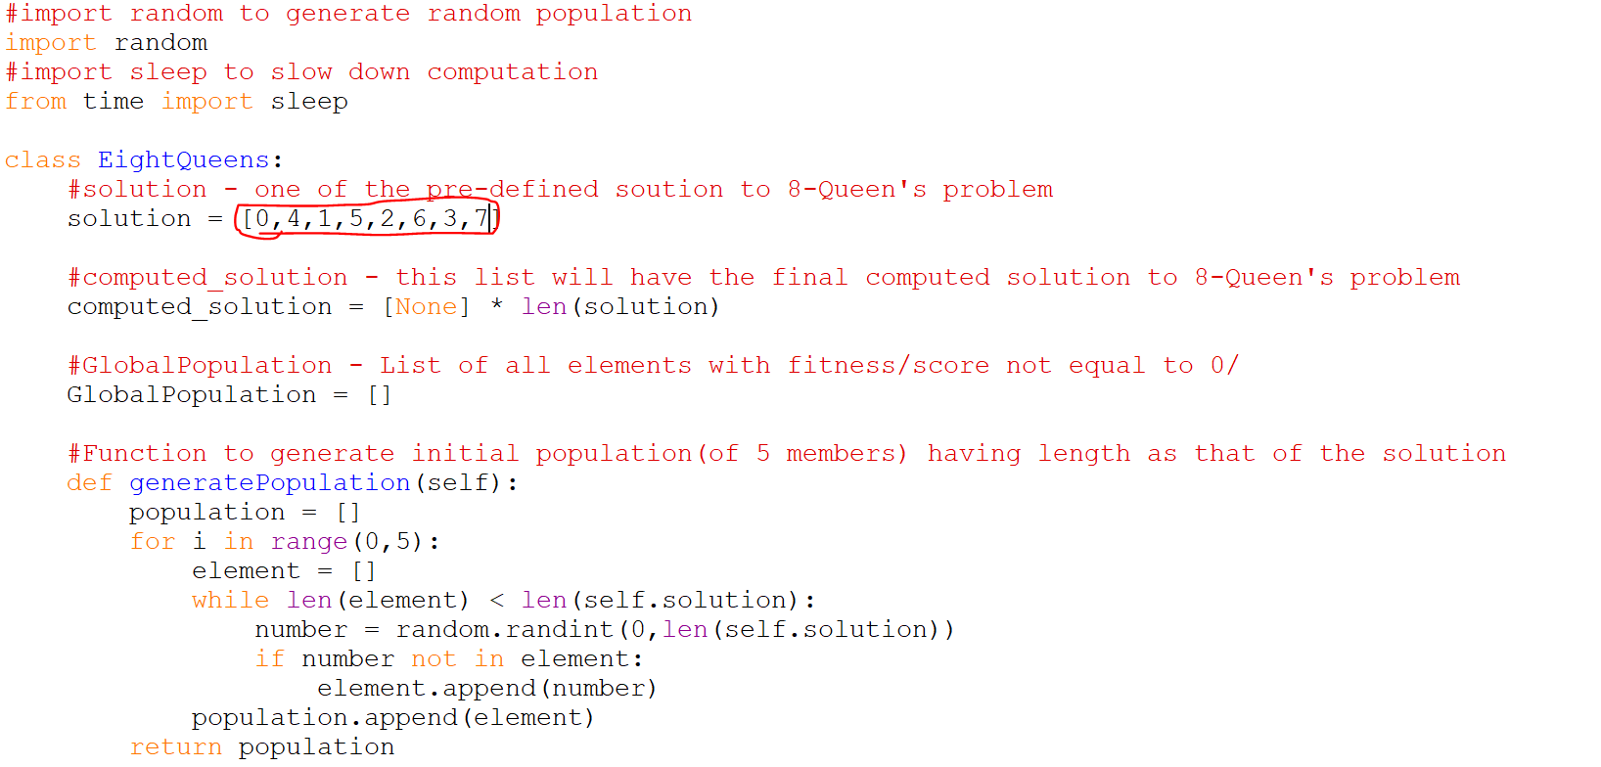

Output of the code changed:

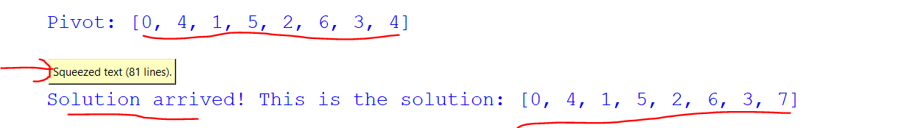

Conclusion: The code works for alternate solutions.

Test Case 3: No part of the code is Hard-coded except for the solution parameter.

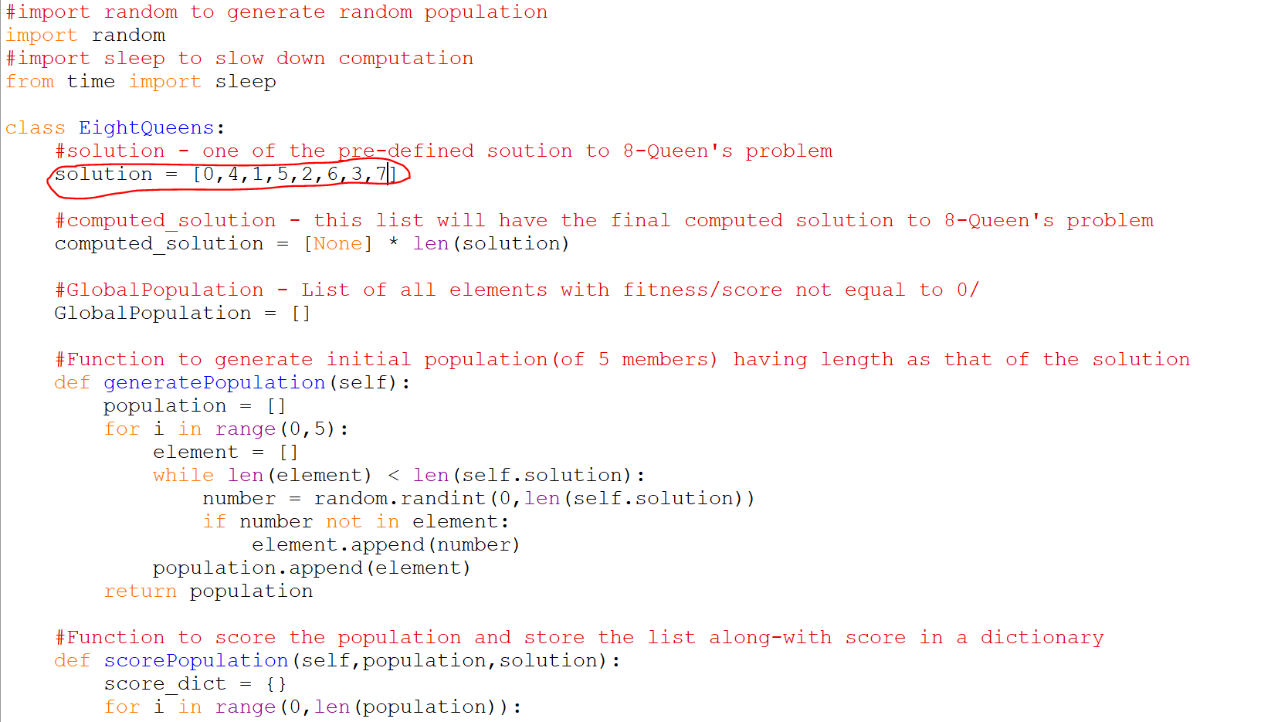

Conclusion: This makes the code very dynamic in nature.